Group 2 Capstone+

New Prob. Statement:  
Teachers are getting more burned-out due to them having to do too much work. Work may include marking test papers, pressure from parents/guardians or authorities, as well as doing too much administrative work and trying to maintain classroom discipline. Burnout may lead to a lack of motivation to continue teaching, decreasing the quality of education, making students feel less inspired to learn.

Potential Solution:  
The work of the teacher can be automated. This may be done through creating multiple systems like a system which automatically marks test papers and worksheets for teachers, or a system which automatically creates a simple lesson plan for the teacher after they input certain ideas and concepts.

**Students have to be inspired to learn → Go down path of subject OR Be a teacher → more ppl. Inspired to teach → more teachers → school hire more teachers → more GOOD teachers → surplus of good teachers → more teachers can be sent to underdeveloped countries**

Potential reasons why teachers may be burnt-out (useful for potential qs)

1. Sub. teacher (25%)
2. Too many lessons (28%)
3. Adapting to students’ needs (31%)
4. **Lesson Prep. (33%)**
5. **Parents/Guardians matters (34%)**
6. **Classroom Discipline (38%)**
7. Authority’s changes (41%)
8. **Too much work (grading/marking) (41%)**
9. **Held responsible for students success (44%)**
10. **Too much administrative work (49%)**

***INTERVIEW***

Aim:

1. Find out source of stress for teachers
2. Find out why source may be stressful
3. Find out potential solutions to problem

Potential Interview teachers

Mr Ang (Sci.), Mdm Siti (Math IC), Mr Keith Lim (Sci.), HSC (Chinese), Mr Chan (CS+), Ms Tan (CS+), Mdm Goh (Bio.), Ms Audrey (Hist. and Lit.), 马老师 (Chinese), Mr Tan Kay Yen (BB Teacher + 2-4 FT + Sci/Bio Teacher)

Potential qs:

STAGE 1: Starting Qs.

1. How long have you been teaching for in general?
2. What is your schedule for teaching?
3. On average, how long do you spend teaching in school?
4. How many classes on average do you teach per day?

STAGE 2: Sources of Stress and Why

3. Disciplinary Matters

1. For the range 2017 - 2019, how many students did you have to address to the principal and parents due to discipline? (estimate)
2. For the range 2020 - 2022, how many students did you have to address to the principal and parents due to discipline? (estimate)
3. Why do you think that there is (an) increase/decrease/no change between the numbers?
4. **Is it challenging to address students' discipline?**

**From the range of 2017 to 2019 and 2020 to 2022, what is the general trend of serious discipline cases? Why would you say so?**

4. Pressure for Success of Students

1. What is the percentage of students in your form class and/or subject classes you would say is not doing well in academic and behaviour terms?
2. Of those students, what percentage of them have parents who complain that you don’t teach well?
3. Who do you think is the reason that students do not do well? Explain.

**How much pressure do you face in terms of the success of students from parents? Why do you think so?**

5. Work

1. How long do you spend planning for lessons, on average?
2. After an examination is over, how long do you take to mark one cohort of students’ test papers?
3. In 2022, during Marking Day, how long do you take to mark every paper that you are assigned to?
4. What would you say describes marking test papers?

Explain.

1. On average, how long does it take to address administrative issues?

* **Break down the average work day in terms of percentages (marking/grading, administrative issues, preparing for lessons)**
* **Do you feel stressed out preparing to teach? Why?**
  + **Very Strong Yes**
  + **Strong Yes**
  + **Medium Yes**
  + **Weak Yes**
  + **Very Weak Yes**
  + **Very Weak No**
  + **Weak No**
  + **Medium No**
  + **Strong No**
  + **Very Strong No**

Alternative: Hybrid (F2F, Google Forms) <https://docs.google.com/forms/d/1WKbmOGv1gsaorcixMtajxOy1VOWF2xvC1sG_0GcPsJM/edit>

RESULTS

People involved: 10 teachers (6 from GESS, 4 from FPPS)

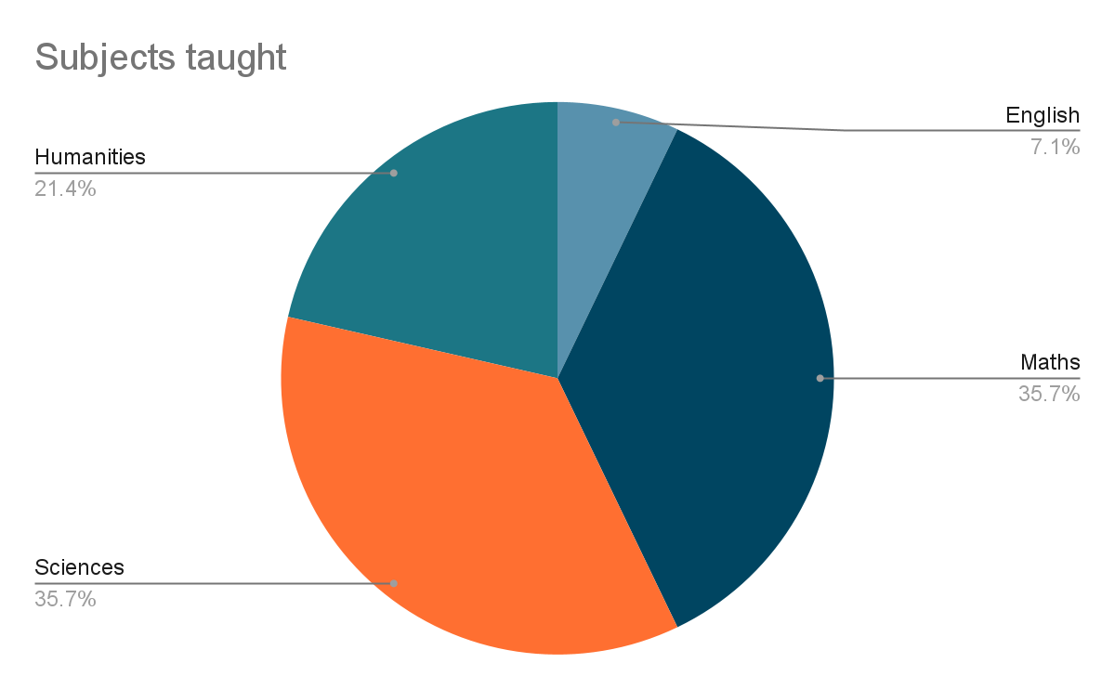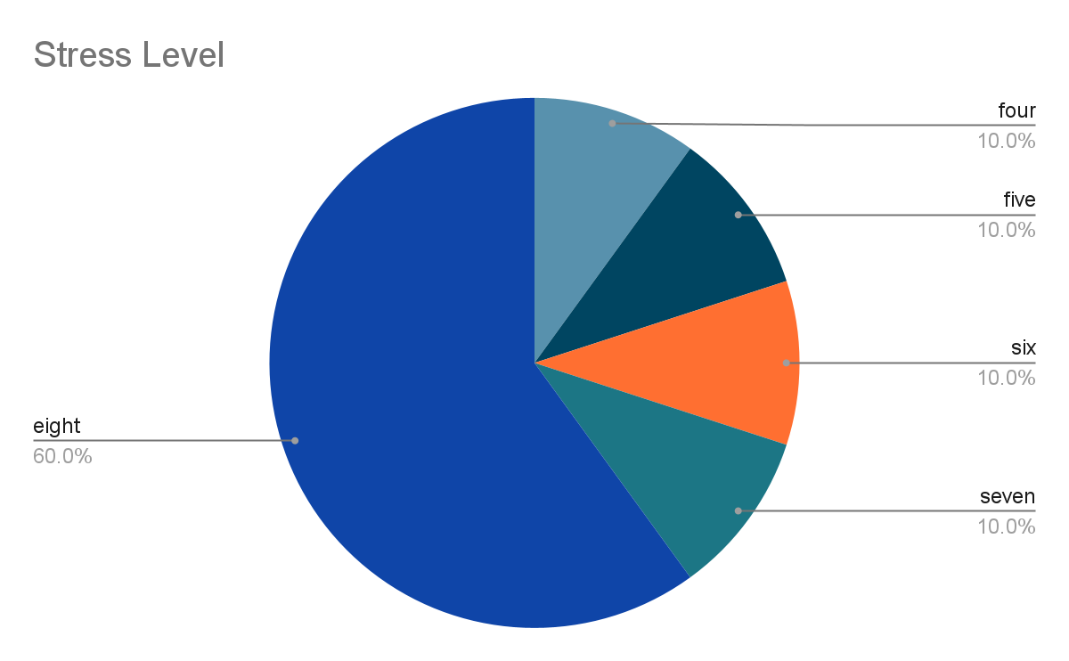

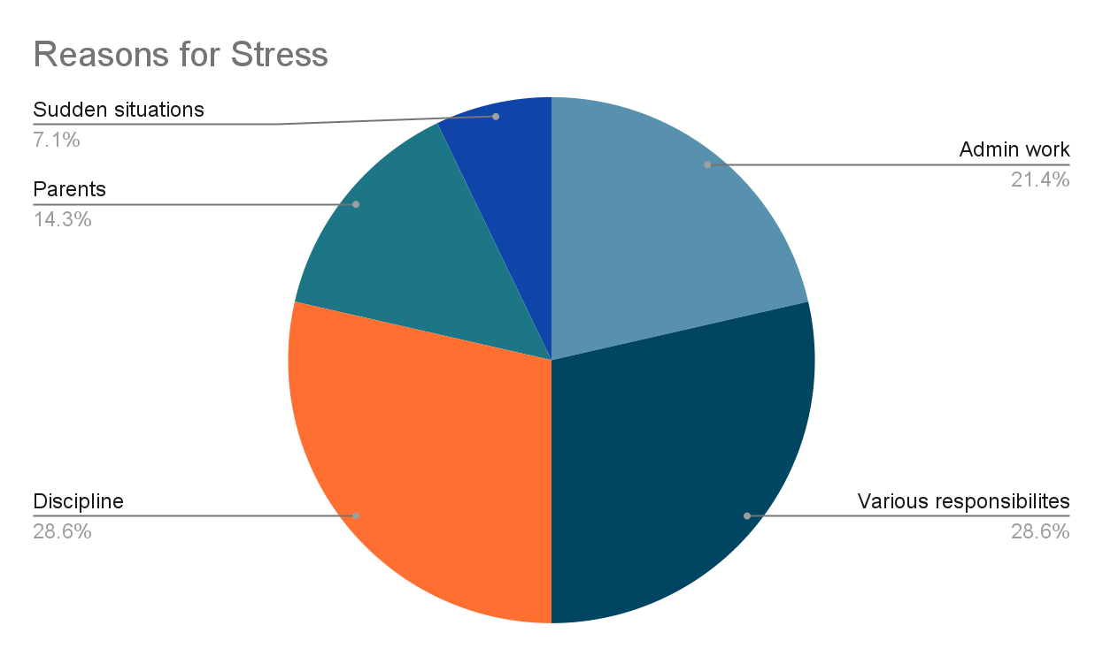

1. <https://files.eric.ed.gov/fulltext/EJ1287736.pdf>
2. <https://www.channel4.com/news/teachers-suicide-rates-double-in-a-year>
3. <https://medium.com/invisible-illness/the-top-ten-stressors-for-teachers-4195490f70e7>
4. <https://research.com/education/teacher-burnout-challenges-in-k-12-and-higher-education>

Group End-Product

* Something to do with discipline